1.Merge Two Sorted Lists

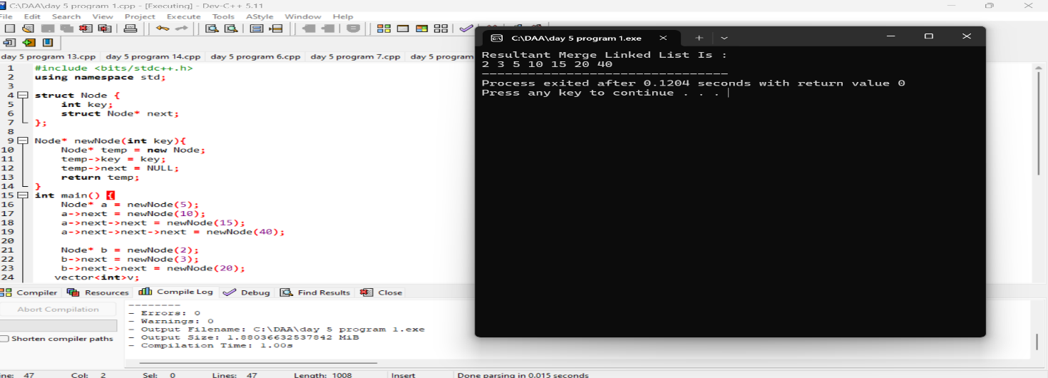

2.Merge K Sorted List

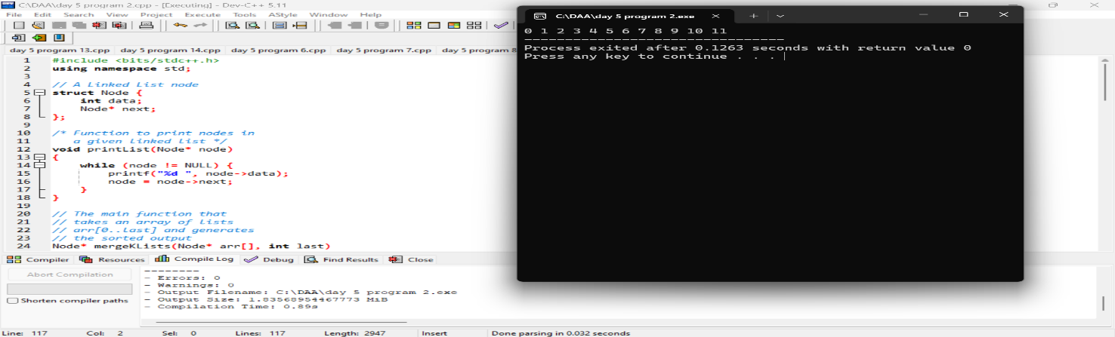

3.Remove Duplicate From Sorted Array

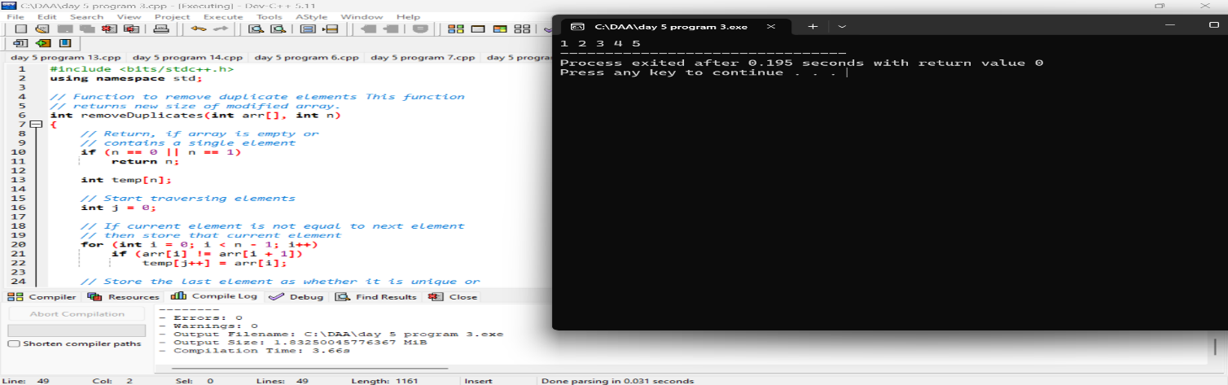

4.Search in Rotated Sorted Array

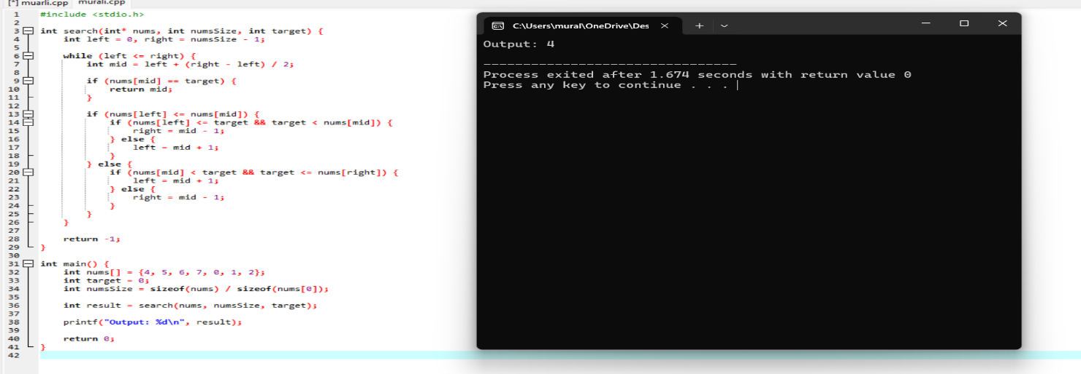

5.Find First and Last Position of the Sorted Array

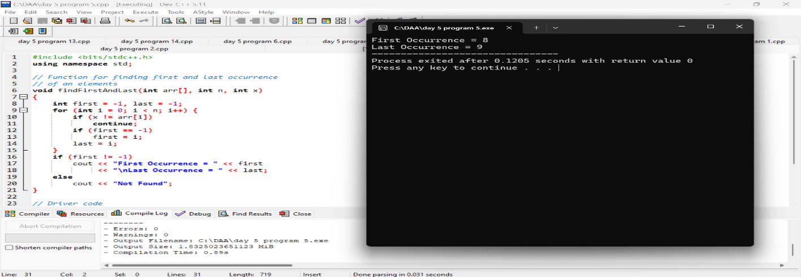

6.Sort Colors

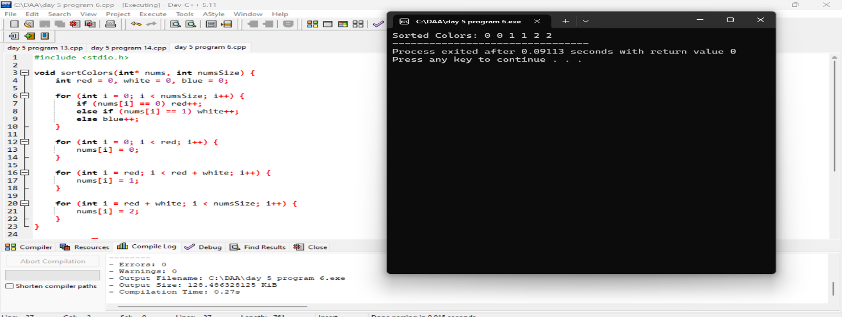

7.Remove Duplicate from Sorted List

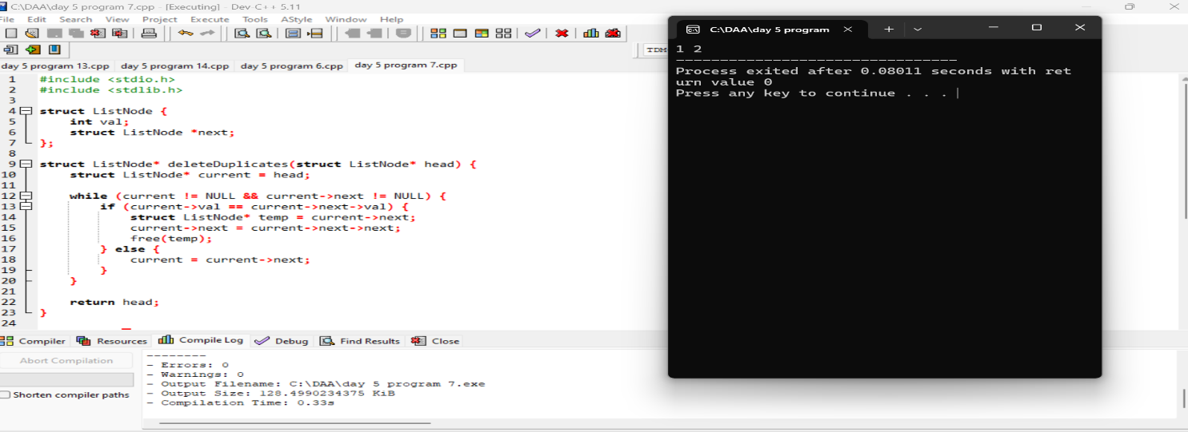

8. Merge Sorted Array

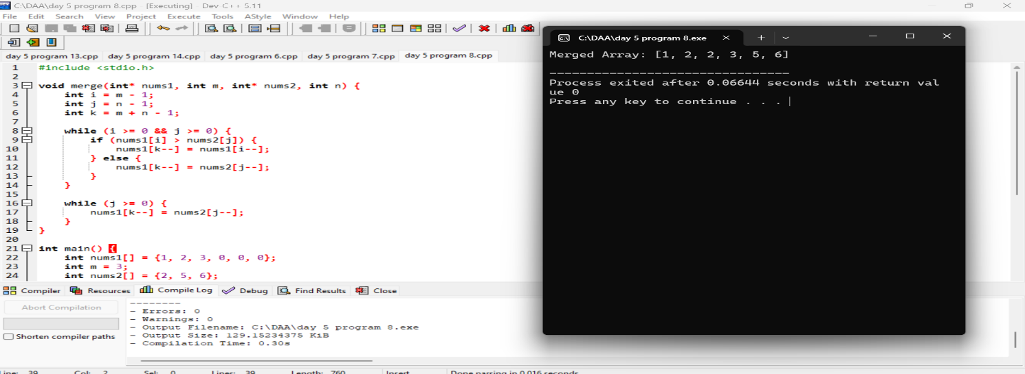

9.Convert Sorted Array into Binary Search Tree

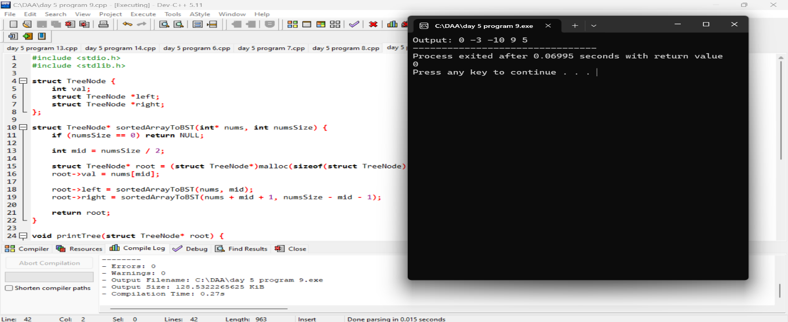

10. Insertion Sort list

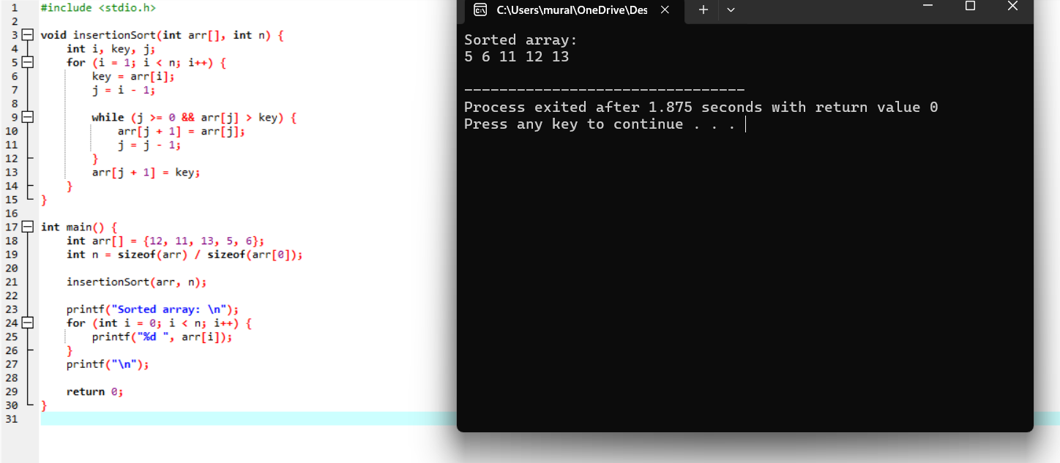

11. Sort Character by Frequency

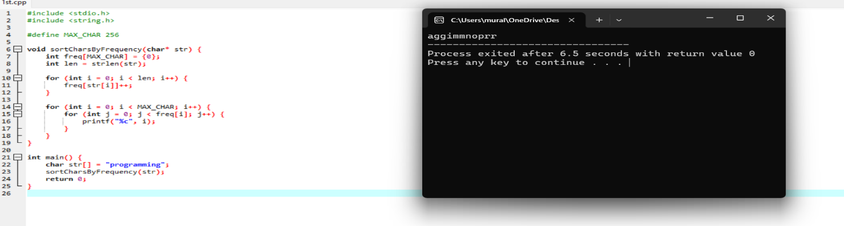

12.Max Chunks to make Sorted

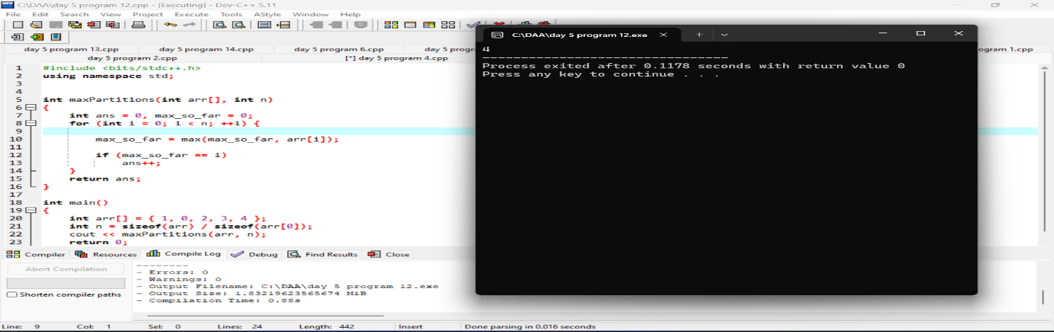

14. Sort the Matrix Diagonally

